Book a Teacher

**Bootstrap Assignment**

The three sections of UXWID students at Champlain College decided to build a website where they can book any of their respective teachers: Jennifer, Reza and Alicia to help them in their assignments and answer their questions. You are part of section 3 and will be working on 2 pages of the website: the teachers page and booking page using Bootstrap.

Download the [Starter Code from Google Drive](https://drive.google.com/drive/folders/1SosAQHQPKAK1ZBAYlnE-ZKHLe0e0e3r_) or [**from Github**](https://classroom.github.com/a/KDJnuQck)**.** Follow the instructions below using HTML5 standards to perform all of your operations. Use Bootstrap 4 (provided in your folder) to complete the responsiveness and the CSS features for the pages (for Chrome only). See all [Screenshots](https://drive.google.com/drive/folders/1ahXPBtnxvSu0rX6691LY864iltHA8lgw) of the layout on different screens. Refer to [Lect. 12](https://docs.google.com/presentation/d/1dWiw_T8gXRUk-b7U5DSDhCpHMDJiiraHSPhYkfsTJZg/edit#slide=id.g7085ad0595_0_0) and the [Bootstrap index Assignment](https://docs.google.com/document/d/1t_IwdfKCQXHDrRuvPdI_AZyFznSNuNknJhrzKrb8WnY/edit#).

## **Teachers** page

1. Make the main heading of the page stand out more and be centered horizontally on the top of the screen.
2. Set the font of “Book a Teacher” to '[Staatliches](https://fonts.google.com/specimen/Staatliches)' - a Google font.



**FIGURE 1**

1. Create a navigation structure of your choice for your pages for the 3 hyperlinks (example below). Only 2 can be used: “Teachers and Booking. The About should not be usable.



**FIGURE 2**

1. The description of the website entitled “UXWID Teachers” uses two Bootstrap colours: one for the title, and the other for the descriptions. Set the colors as shown (see **FIGURE 3**) or choose your two preferred Bootstrap colors.
2. In the desktop viewport: the image **rja.png** (green image of the three teachers together) should not appear and all the space should be allocated to the description of the website. The images **jennifer.png**, **reza.png** and **alicia.png** (individual images of the teachers) should appear. The image arj.png (orange image of the three teachers together) should not appear (see **FIGURE 3**).

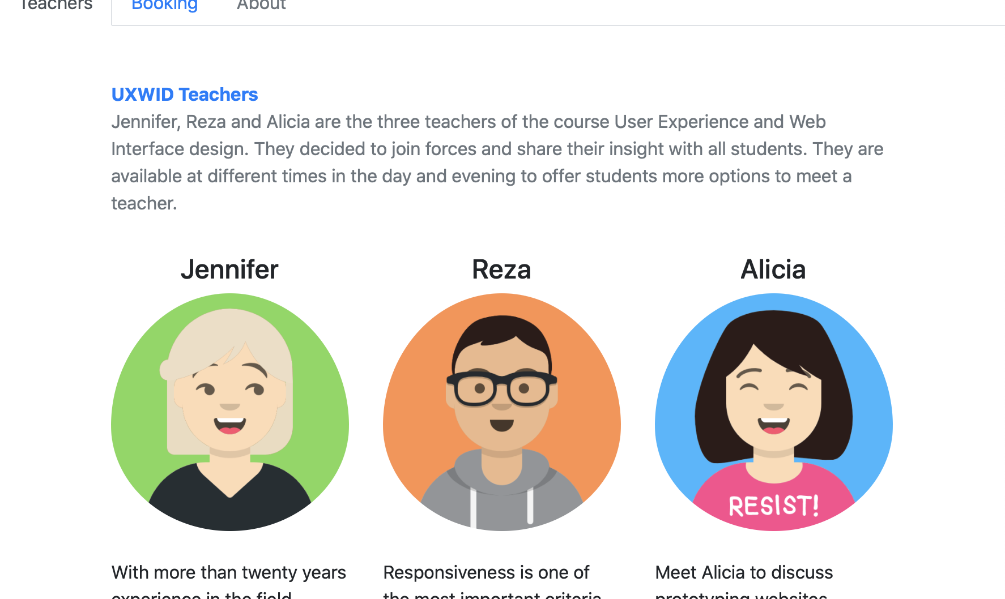

**FIGURE 3**

1. In tablet viewport, the image **rja.png** and website description should each take up 50% of the screen. The images **jennifer.png**, **reza.png**, **alicia.png** and **arj.png** should not appear (see **FIGURE 4**)
2. On the smaller viewports the image rja.png should be removed and replaced by the orange image **arj.png**. (see **FIGURE 5**)

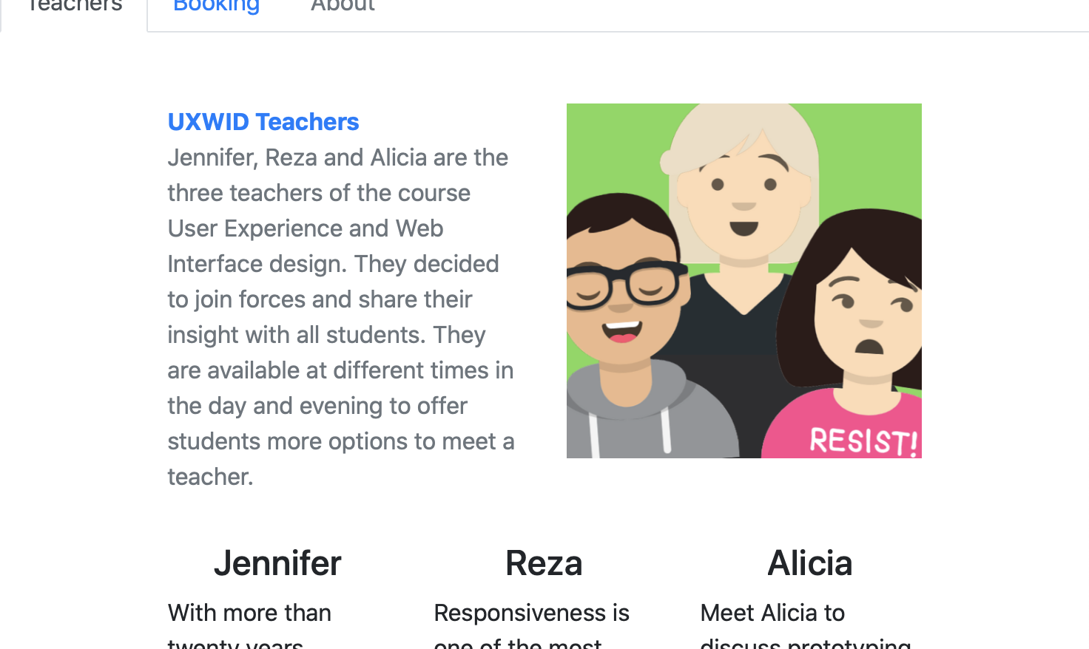

**FIGURE 4**

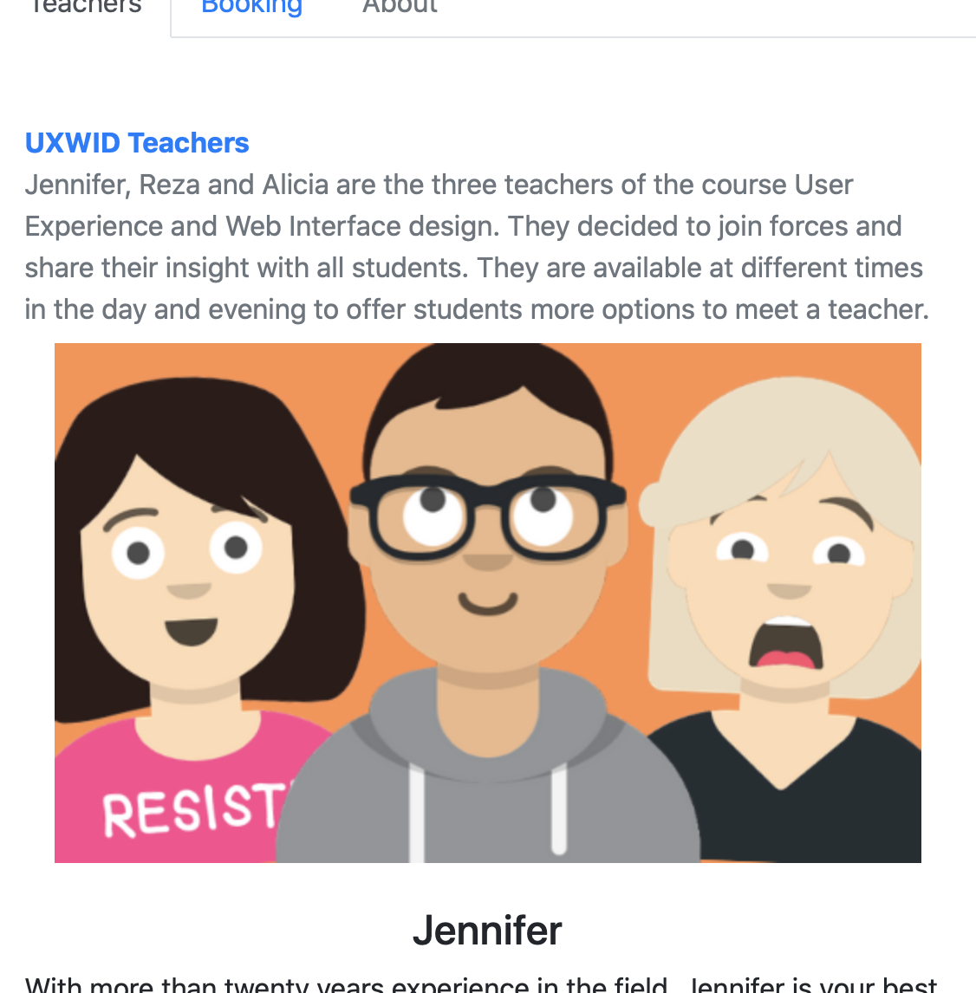

**FIGURE 5**

1. The 3 individual images of the teachers should not have square corners. Make sure they resize as the page resizes (see **FIGURE 6**).



**FIGURE 6**

1. Add a button to email each of the teachers individually (see **FIGURE 7**)

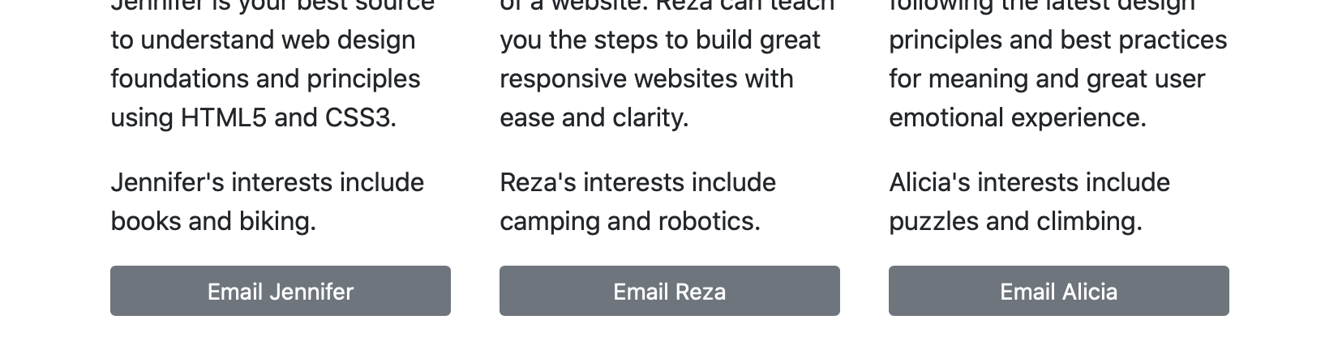

**FIGURE 7**

1. The footer should be placed as shown below (see **FIGURE 8**).



**FIGURE 8**

1. Add space between the <nav> and <main> and the <main> and <footer>. Do not use <br>s.

## 

## **Booking** page

Use the same heading and navigation structure as on the teachers page. Use the same spacing between the <nav>, <main> and <footer>.

1. The heading of the form should be the same as the main heading on the page and horizontally centered over the form except for the color (see **FIGURE 9**).

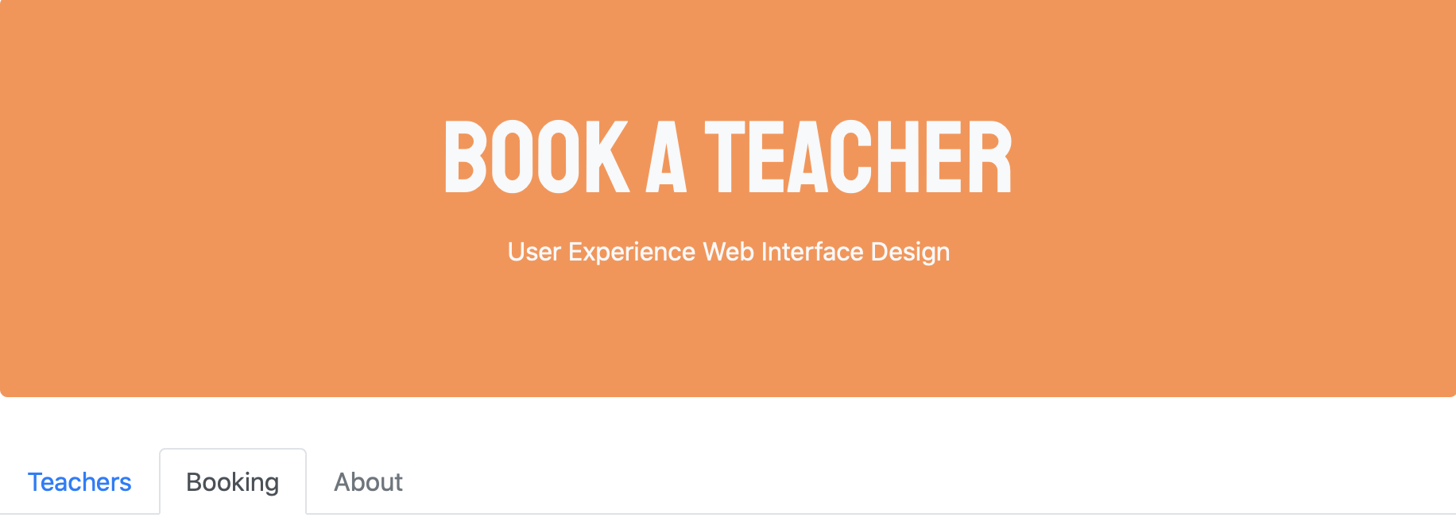

**FIGURE 9**

1. Add all the form controls as shown below (see **FIGURE 10**).

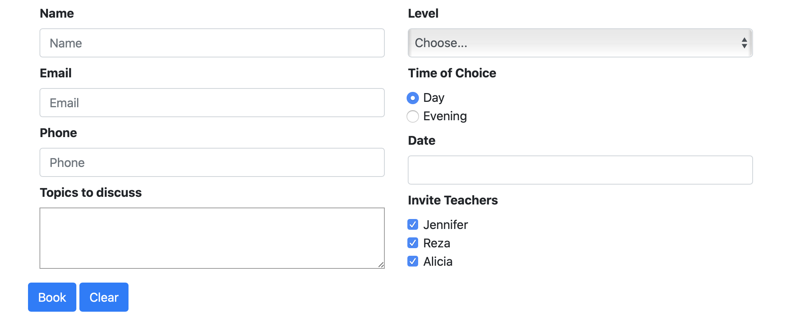

**FIGURE 10**

1. The form should appear to be in 2-column layout in all sizes except for the smallest viewport where it should be stacked. (See **FIGURE 11**)
2. Do not use a text box for the students email address, telephone number, and proposed date. Use HTML5 for these controls.
3. Use the following categories for the Level area: Beginner, Basic, Advanced.
4. Make sure there is more space than the default allocates in the Topics to discuss section to allow the student to describe the reason for the meeting if necessary.
5. Day should be the default time and Jennifer, Reza and Alicia should all be invited by default (See **FIGURE 12**)

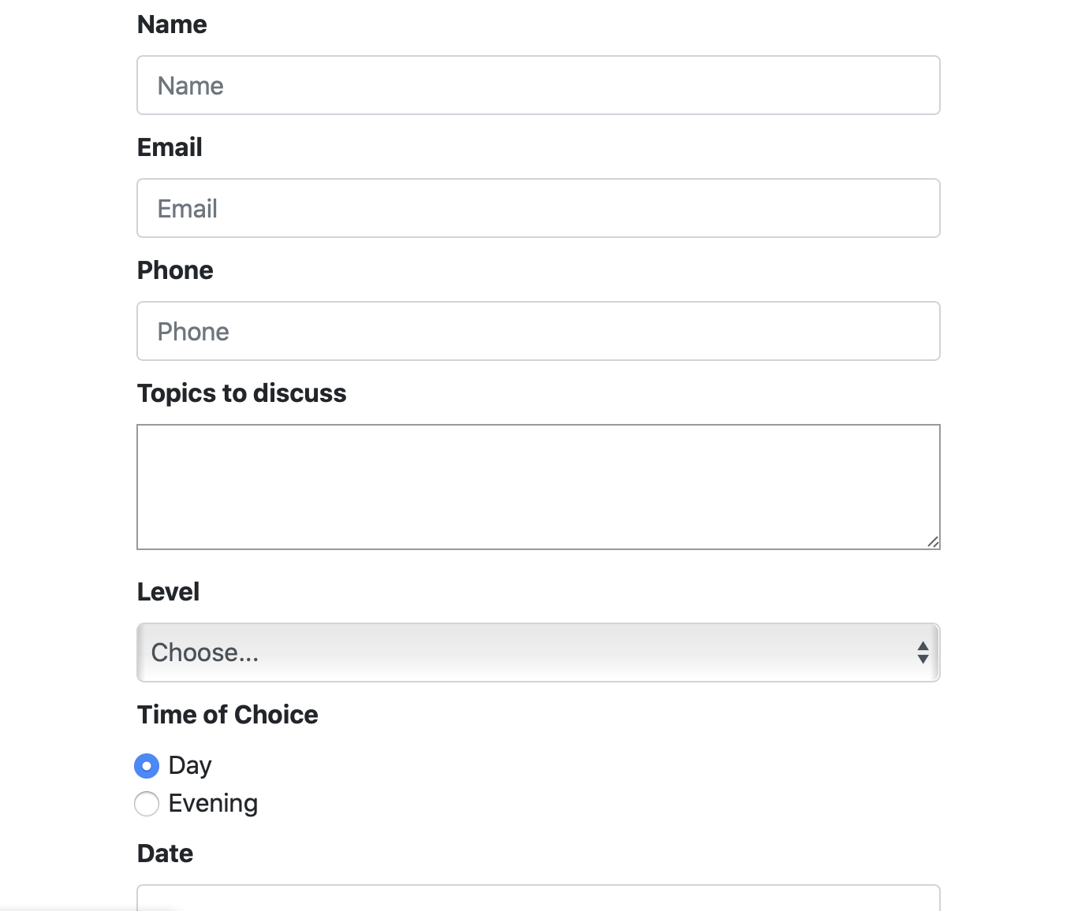

**FIGURE 11**

1. An email address must be provided in order to confirm the appointment.
2. Provide accessibility features to your users.
3. Place the Book and Clear controls as shown (see **FIGURE 12**).

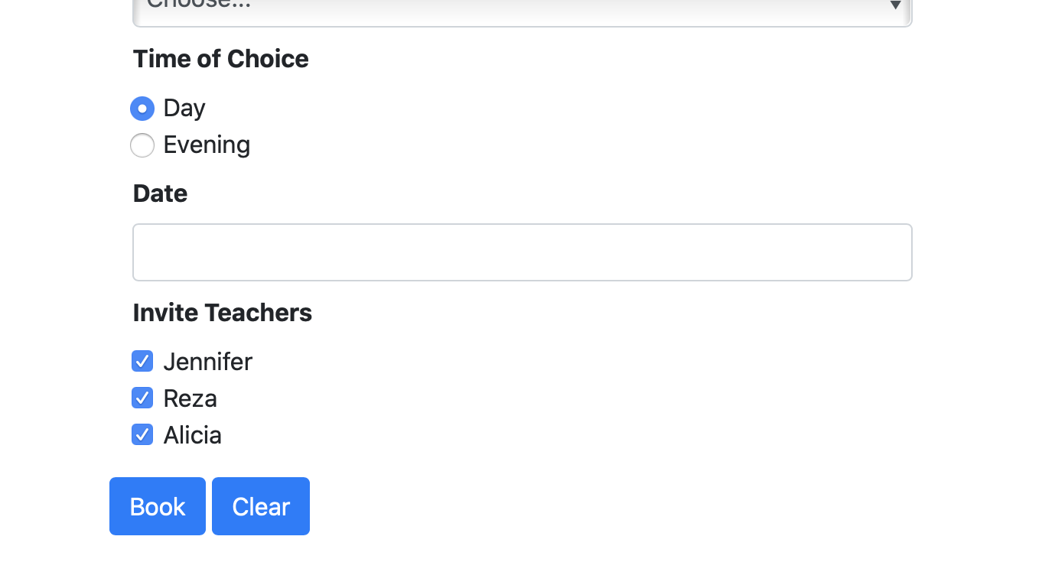

**FIGURE 12**

## Submission Deadline

[**Submit HERE**](https://classroom.github.com/a/KDJnuQck) **by Tuesday December 3rd at 2:30pm. You will only have 30 minutes if you intend to start working on this assignment during the lab session**.